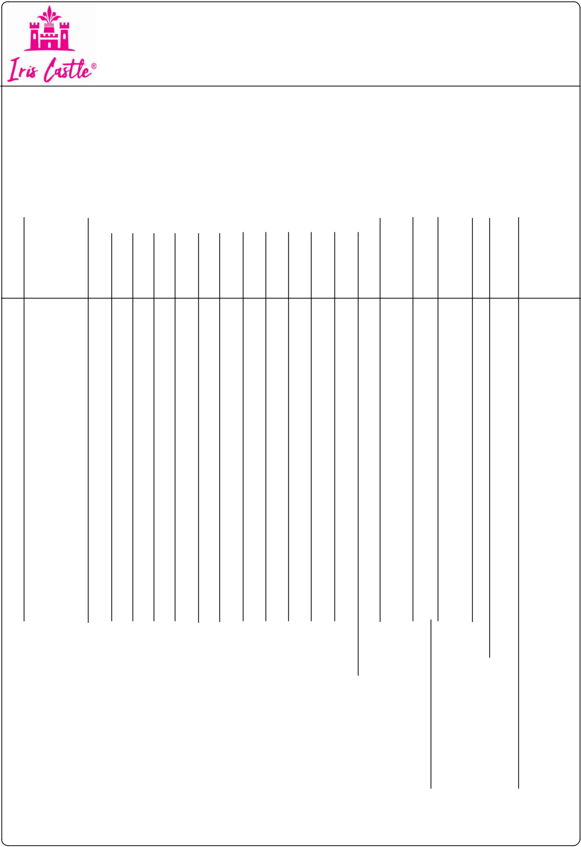
|| SHREE GANESHAY NAMAHA ||

TAX INVOICE

VAARA CLOTHING

2ND FLOOR,SHOP NO.S-12,OM ANNEX,GARAGE GALLI,DADAR (W),MUMBAI-400028 TEL : 9699996996 / 9167668982 / 9819420855 Email:iriscastles@gmail.com

GST NO:- 27BQVPM9699H1ZJ |  |  |  |  |  |  |  |  | HSN CODE:-
 |  |  |  |  |  |  |  |  | 6204
Billing Address : |  |  |  |  |  |  |  |  |  | Invoice No:.-793 |  | Date :-28/12/2023
M/s. MAJISA BEAUTY ZONE |  |  |  |  |  |  |  |  |  | Lr.No. | :- | Date :- / |  | /
OPP. ASHIRWAD MALL,OLD BUS STAND
 |  |  |  |  |  |  |  |  |  | Parcle | :-
VILLAGE- CHIKHLI, TALUKA-CHIKHLI, |  |  |  |  |  |  |  |  |  | Parcle | :-
NAVSARI-396521 |  |  |  |  |  |  |  |  |  | Transport :-MAHAVIR ANGADIA
STATE | :- GUJARAT-24 |  |  |  |  |  |  |  |  | Broker :- PRAVIN
STATE |  |  |  |  |  |  |  |  |  | Remove Date :- 28/12/2023
TELE NO. :- 9898977858
 |  |  |  |  |  |  |  |  |  | Place to Supply :-GUJARAT-24
GST NO | :- 24CCUPP8005L1Z0
Sr. Design No. |  |  |  |  |  |  |  | Size |  | Rate | Disc N.Rate Gst ^{Qty} |  |  | Amount
 |  |  | 18 | 20 | 22 | 24 | 26 | 28 30 32 34 36 | 38 40 |  | % | %
 | 16 |  |  |  |  |  |  |  |  |  | % | %
1 | EI-71 |  | 1 | 1 | 1 | 1 | 1 | 1 | 950 |  | 950.00 | 5 | 6 | 5700.00
GREEN3PCS
2 | EI-34 |  | 1 | 1 | 1 | 1 | 1 |  | 1050 |  | 1050.00 | 12 | 5 | 5250.00
BLUE3PCS

 | 5 % AMT. | 5700.00 | 5%QTY | 12 % AMT. | 5250.00 | 12%QTY | 10950.00 | 1110950.00
 |  |  | 6 |  |  | 5
 | 5% TOTAL | 5700.00 |  | 12% TOTAL | 5250.00 |  | TOTAL | 10950.00
 |  |  |  |  |  |  | IGST 5% | 285.00
 | 1. Payment Within | _{30 Days.}SUBJECT TO MUMBAI JURISDICTION |  |  |  |  | IGST 12% | 630.00
  - In Case of unpaid bill interest @ 24% will be charge extra from the date of bill.
3.Payment of this bill will be accepted only by payee A/c or draft.

4.Goods once sold not be taken back.

- Once the goods are delivered We are not responsible for any claim.

6.Customers are requested not to deduct discount on net amt |  |  |  | Round Off....
^{Amount (In Word):-} Eleven Thousand Eight Hundred Sixty Five Only |  |  |  | NET TOTAL | 11865.00
 |  | OUR BANK | : IDBI BANK
 | Certified that the particulars given above | OUR BANK | : IDBI BANK | FOR VAARA CLOTHING
 | are true& correct & the amount indicated | BRANCH | : PRABHADEVI,MUMBAI-400028
 | represents the price actually charged & | A/C NO. | : 0579102000008969
 | there is no flow of additional consideration | A/C NO. | : 0579102000008969
 | directly or indirectly from the buyers. | IFSC CODE | : IBKL0000579 | Authorised Signature

